Class – III
SUBJECT | SUMMER HOLIDAY HOMEWORK
English | Do the given worksheets  Roll no. 1 to 6 Make a Chart on Adjectives  Roll no. 7 to 11 Make a Chart on Nouns  Roll no. 8 to 15 Make a Chart on Verbs & Adverbs  Rhythm in writing Book: Do pg no 11,12,13,16,17,28,29,30,32,33,34,35 &36
Hindi | Do the given worksheets.  Roll No. 1 to 5 : Make a chart on - fyax foykse “kCn i;kZ;okph A  Roll No. 6 to 10 : Make a chart on- Loj O;atu ek=k,W fyax A  Roll No. 11 to 16 : Make a working model on- Loj O;atu opu fyax A
Mathematics | Do the given worksheets. Learn Tables from 5-15.  Projects:- Roll no. 1to 3 – Make a working chart/model on Division.  Roll No. 4 to 6 – Make a working model on Addition & Subtraction.  Roll No. 7 to 9 – Make a 3-D model on Fractions.  Roll no. 10 to 12 – Make a working chart/model on Geometry.  Roll no.13 to 15 – Make a working model on Time.
Social Studies | *Do the given worksheets.  Roll no. 1- Make a chart on Culture of India  Roll no 2:- Make a chart on travel and Communicate  Roll no 3:- Make a chart on Metro Cities  Roll no. 4: Make a model of India Gate. ( take help from page 62)  Roll no. 5:- Make terracotta Pot ( take help from page 82 )  Roll no. 6: Make a chart on occupations in India  Roll no. 7: Make a chart on Early Humans  Roll no. 8:- Make a chart on Our Culture  Roll no. 9:- Make a diorama on water ( take help from page 32)  Roll no. 10:- Make a chart on occupations in India  Roll no. 11:- Make a chart on Early Humans  Roll no.12:- Make a working model on transportation take help from you tube, Roll no. 13:- Make a working model on transportation take help from you tube, Roll no. 14:- Make a model on India showing different physical features,  Roll no. 15:- Make a working model on water cycle.
Science | Do the given worksheets.  Roll no. 1 to 3 Make a working model of a windmill.  Roll no. 4 to 6 Make a working model of a well.  Roll no. 7 to 9 Make a working model of a water Dispenser.  Roll no. 1 to 3 Make a model of a water cycle.  Roll no. 1 to 3 Make a working model of an Eco-friendly House with windmill, solar panel
Computer | (Roll No. 1 - 5 ) Make a Model on MS paint i.e. fig. 7.2 on page 87.  (Roll No. 6 - 10 ) Make a Model on component required to connect internet.  (Roll No. 11 – 15 ) Make a Model on Hardware and Software.
General Knowledge | (Roll No. 1 - 5 ) Make a chart on currencies.  (Roll No. 6 - 10 ) Make a chart on abbreviations.  (Roll No. 11 – 15 ) Make a chart on spices.  Write 20 current affairs in your G.K. notebook.

The Jain International School , Kanpur
Subject: English
Holiday Homework Worksheet 1
Class – III
Name:- ___________________ Date: _______________
SENTENCES
Read these sentences. Mark S for statement, Q for question, C for command, R
for request and E for exclamation:-

1. Leave the class at once.

2. What a beautiful scenery!

3. Where is your school?

4. Please advise us on this matter.

5. I live in a little house over the hill.

6. Who made this mess?

7. Latika walks to the station.

8. What a pleasant morning!

9. Will you help me carry the bag!

10. Raghu goes by the school bus.

Tick the group of words which make complete sentences:-

1. Cloudy sky

2. I need an umbrella.

3. Heavy school bag

4. He is a good player.

5. A good TV programme.

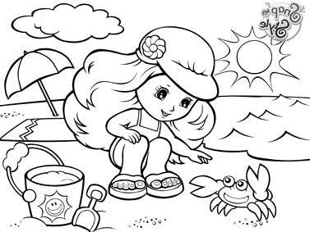
6. We go to the park eve
The Jain International School , Kanpur
Subject: English
Holiday Homework Worksheet 2
Class – III
Name:- ___________________ Date: _______________
ARTICLES
Fill in the blanks with a, an or the:-
1. I saw strange bird yesterday.

2. Sun gives us light and heat.

3. Do you have umbrella?

4. Is there any milk in fridge?

5. He is drinking cup of coffee.

6. I will have apple and banana for lunch.

7. Jhelum is river in state of Punjab.

8. I want to be pilot. My friend wants to be astronaut.

9. Sahil is tallest boy in his class.

10. I have friend who lives near Quest Mall.

Tick the correct option:-
1. a/an coin

2. a/an hour

3. a/an owl

4. a/an brush

5. a/the Himalayas

6. a/an tent

THE JAIN INTERNATIONAL SCHOOL
HOLIDAY HOME WORK
CLASS-3
Sheet No.1

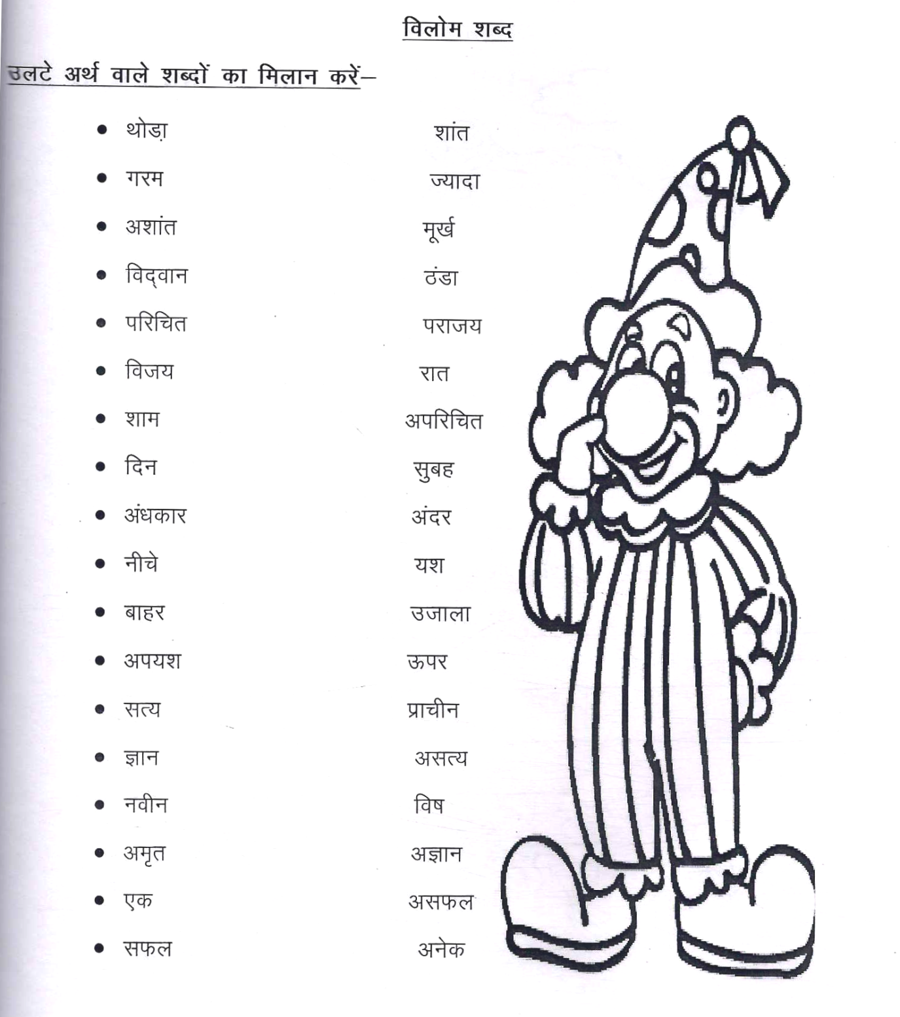
THE JAIN INTERNATIONAL SCHOOL
HOLIDAY HOME WORK
CLASS-3
Sheet No.2

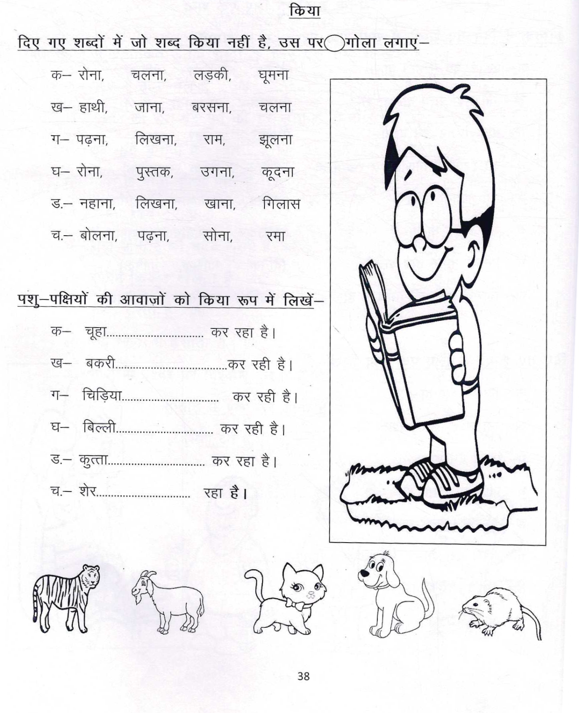
The Jain International School , Kanpur
Subject: Mathematics
Holiday Homework Worksheet 1
Class – III
Name:- ___________________ Date: _______________
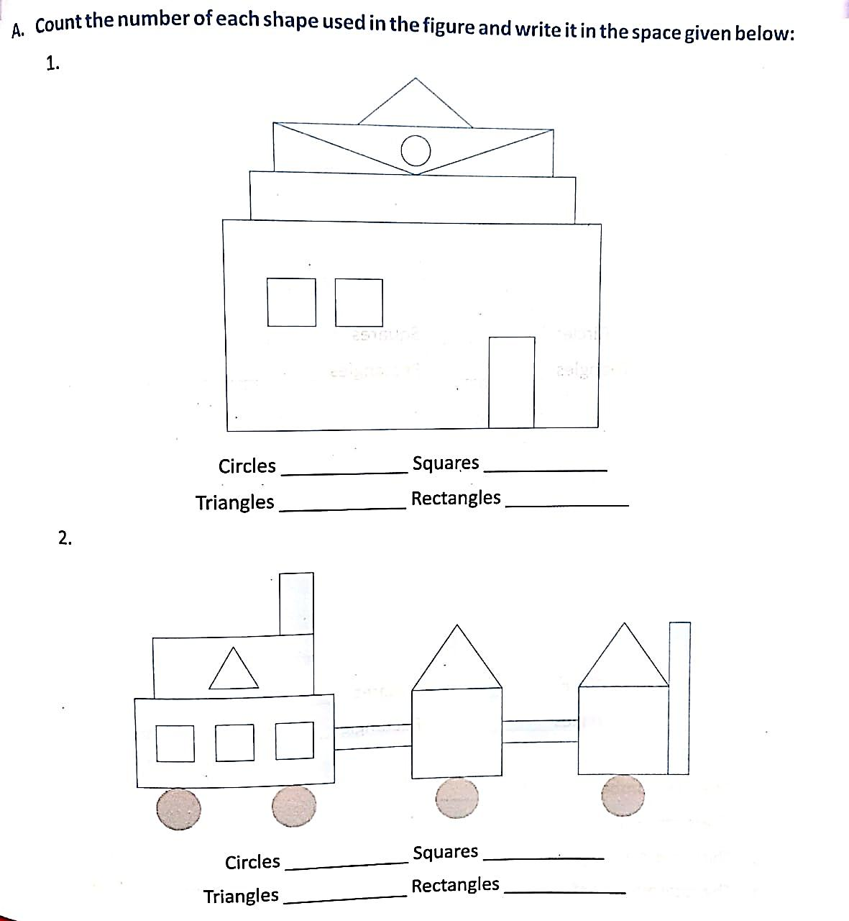

The Jain International School , Kanpur
Subject: Mathematics
Holiday Homework Worksheet 2
Class – III
Name:- ___________________ Date: _______________
______________________________________________________________________________

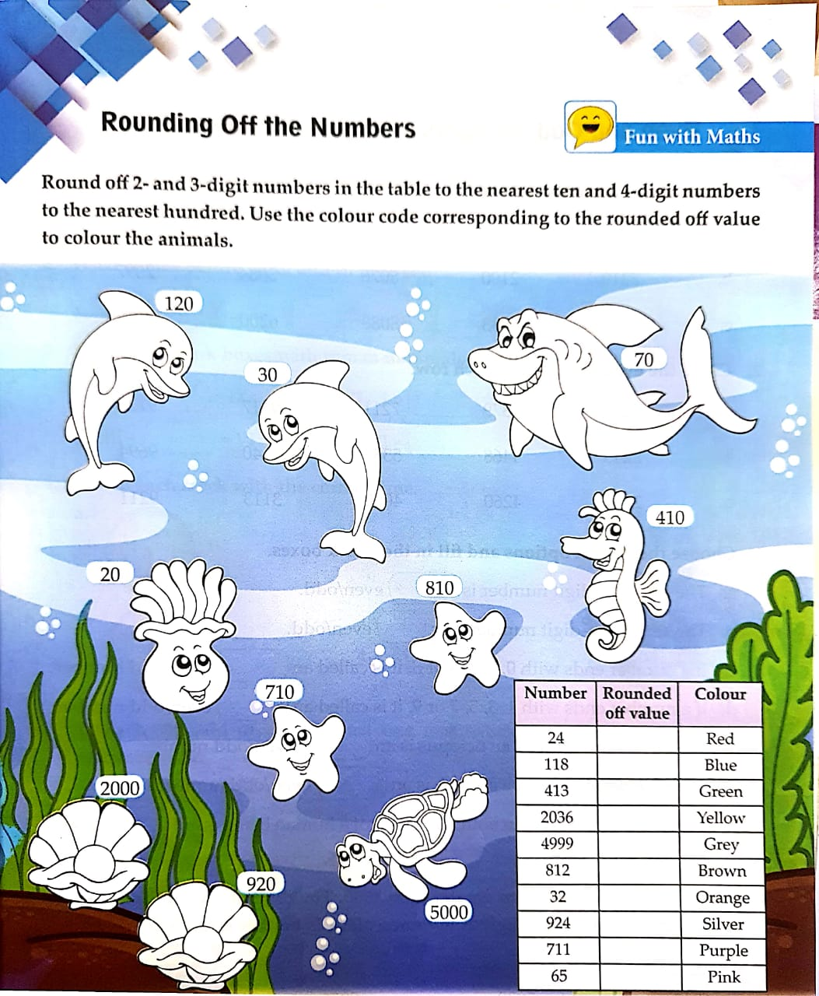
The Jain International School , Kanpur
Subject: Social Studies
Holiday Homework Worksheet 1
Class – III
Name:- ___________________ Date: _______________
___________________________________________________________________________________
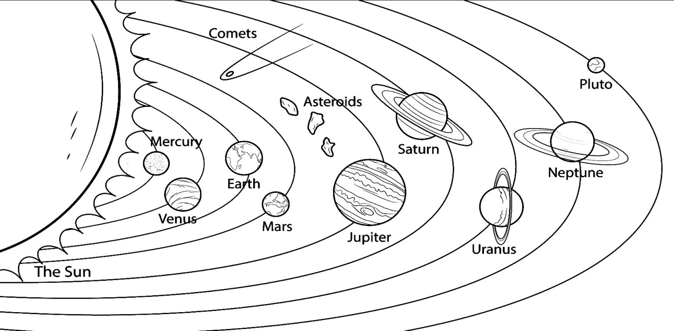

Choose the correct word from the help box and fill in the blanks:-

first second third fourth

fifth sixth seventh eighth

1. Mars is the planet from the Sun.

2. Venus is the planet from the Sun.

3. Jupiter is the planet to the Sun.

4. Mercury is the planet to the Sun.

5. Earth is the planet from the Sun.

6. Neptune is the planet from the Sun.

7. Saturn is the planet to the Sun.
8. Uranus is the planet to the Sun.
The Jain International School , Kanpur
Subject: Social Studies
Holiday Homework Worksheet 2
Class – III
Name:- ___________________ Date: _______________
___________________________________________________________________________________
MAPS
Use the map of the neighbourhood below to answer the questions:-
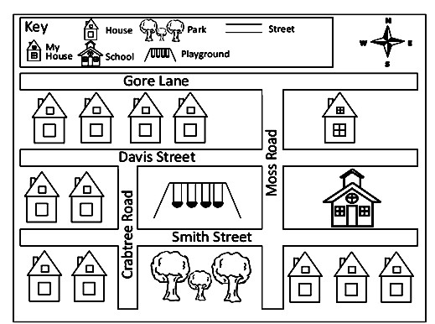
1. My house is of the school {North, South, East, West}

2. The_ is south of the playground.

3. To get from my house to school, you must cross Street.

4. The school is of the playground. {North, South, East, West}

5. How many houses are West of Crabtree Road?

6. How many houses are South of Smith Street?_

7. The playground is and of my house.

{North, South, East, West}
8. The school is is and of the park. {North, South, East, West

The Jain International School , Kanpur
Subject: Science
Holiday Homework Worksheet 1
Class – III
Name:- ___________________ Date: _______________
______________________________________________________________________________

THE WORLD OF PLANTS

Write one example of each of the following:-

1. Big plant-

2. Small plant-
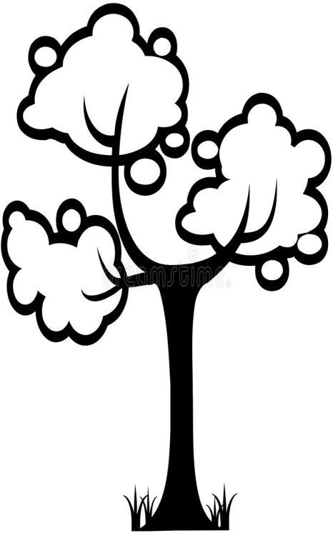
3. Climber-

4. Creeper-

5. Herbs- ______________________________________________________

State True or False:-

- Plants grow from fruits- _________________________________

2. A plant needs sunlight, air and water to grow- ___________________________________

3. Rose plant is a creeper- _______________

4. The leaf makes food for plants- _______________

5. Coconut tree is a big plant-

Who am I:-

1. I fix the plant to the ground- _______________

- I need the support of a wall or stick to grow- _______________

3. I change into a fruit- _______________

- I prepare food for the plant- _______________
The Jain International School, Kanpur
Subject: Science
Holiday Homework Worksheet 2
Class – III
Name:- ___________________ Date: _______________
______________________________________________________________________________
FOOD AND SHELTER FOR ANIMALS
Choose the words from the help box and fill in the blanks:-
air food water shelter soil

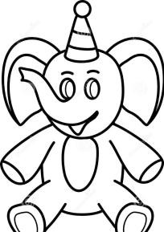
All living things need to drink.

All living things need to eat.

All living things require to live in.

All plants require to grow.

All living things need to breathe.
List any 4 living things:-
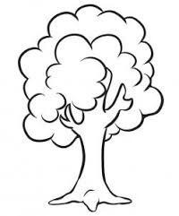

List any 4 non-living things:-

